# **What is a Neural Network**

This straight line tends to go to negative, but price of a house cannot be negative.

# **Super-vised Learning with Neural Networks**

Real estate and Online Advertising 🡪 Standard Neural Network  
Photo tagging 🡪 Convolutional Neural Network  
Speech and Machine Translation 🡪 Recurrent Neural Network  
Autonomous Driving 🡪 Custom Hybrid Neural Network

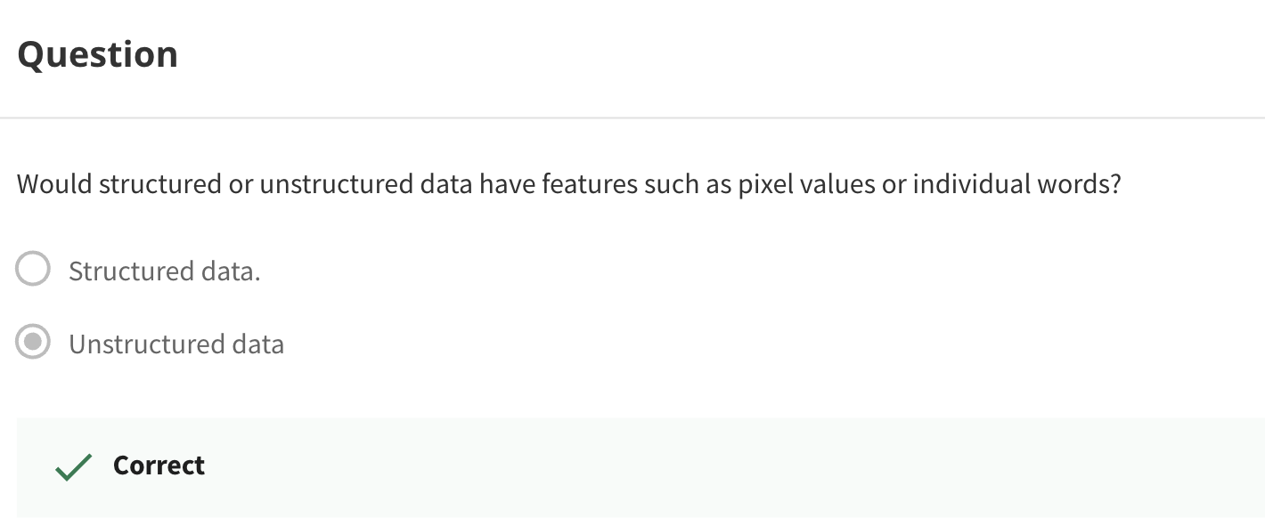

# **Why is Deep Learning taking off?**

# **Quiz**